WORLD BOOK

World Book was selected to continue to provide the Tennessee Electronic Library a suite of encyclopedia products for the residents of Tennessee through May 31, 2021. World Book offers unique content and features for patrons of every age, ability and interest. Using the same expert information found in the World Book Encyclopedia, these easy-to-navigate websites offer 24/7 access on smartphones, tablets and personal computers.
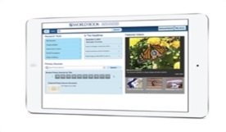
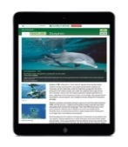
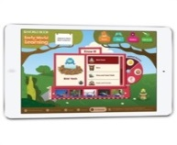
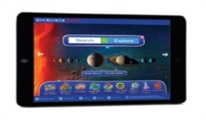

- Early World of Learning encompasses playful interactive learning environments for preschoolers and children in the early elementary grades including Trek’s Travels, Welcome to Reading, and Know It. Each environment is designed for easy integration into classroom and library programming.

- World Book Kids offers easy-to-read articles and a wealth of engaging multimedia, games, science projects, interactive tools, and activities for younger library patrons.

- World Book Student features all the articles from the print version of the World Book Encyclopedia, plus thousands of additional articles, learning resources, and research tools to help older elementary and middle school students develop their research skills.

- World Book Advanced includes full encyclopedic and multimedia databases supplemented with online books, primary sources, website links, back in time articles, special reports and more to meet the research needs high school age patrons.

- World Book Discover offers engaging reference resources for patrons reading below grade level because of language or learning difficulties, including reluctant readers, English language learners, ESL, and adult literacy patrons. Discover includes reference articles, text-to-speech capabilities, activities, research and translation tools, multimedia, and interactive videos to engage patrons of varying abilities with curriculum-related topics and subjects.

- Enciclopedia Estudiantil Hallazgos offers World Book’s content, rich media, and engaging features in a Spanish language interface designed for grades K–4 as well as older patrons and adults learning Spanish as a foreign language.

- World Book Info Finder is loaded with practical features that will help upper elementary and middle school patrons develop their research skills at the library, such as Dynamic Interactive Earth, which includes the World Book Atlas, Interactive Maps, Outline Maps and Flags.

- World Book Reference Center is designed to meet the needs and skills of library patrons of high school age and above. The site features the entire World Book Encyclopedia, an atlas, a dictionary, e-books, and local and country research guides.

- World Book eBooks includes highly illustrated, engaging titles that span all curriculum areas and reading levels. Read online or download titles to the ebooks app. For grades K-12.

- World Book Timelines - Hundreds of customizable, interactive timelines of important events throughout history. (Optimized for tablets)

